# 

Featured image. Alt-text: Web scrape eBay search results using SerpApi

# Web scrape eBay search results using SerpApi

If the heading **has convinced** you already, then head on over to [SerpApi’s eBay sandbox](https://serpapi.com/playground?engine=ebay) to see what they can offer; otherwise keep on reading…

Here are what a few influential people had to say about data in general:

“Data really powers everything that we do.” – [Jeff Weiner](https://www.linkedin.com/in/jeffweiner08/), CEO of LinkedIn

“Where there is data smoke, there is business fire.” — [Thomas Redman](http://dataqualitysolutions.com/meet-the-data-doc), the “Data Doc”.

## The problem you have as a business owner

As businesses, **it is essential to use data** to help improve profits, keep costs low and stay at the forefront of the industry market. This is true of multi-million corporations as well as sole traders. You can use data to determine where you can:

* Cut costs
* Increase profits and
* Sustain a competitive edge

Imagine you are a coffee bean supplier for a number of coffee shops and you want to update and revise your available inventory by either changing the source where you get your coffee beans from or even adding some additional items that you can start supplying to coffee shops. To do this effectively, you will need data about:

* Current coffee prices from different vendors
* Popular coffee beans seeing high sale volumes

A **free place** to get all this information is [eBay](https://www.ebay.co.uk/). [eBay](https://www.ebay.co.uk/) is a great place where you can do some market research to see what is currently popular and compare prices between different suppliers. One downfall is that [eBay](https://www.ebay.co.uk/) is not really made for in-depth data analysis. The search results are essentially a list of all the items that match your search criteria. You can see some information about the item in the search list like:

* title
* subtitle
* link
* condition
* price etc.

[eBay](https://www.ebay.co.uk/) does not have any statistical tools that you can use to see what coffee is being sold the most, what is the average price of a **bag of** **1kg Arabica roasted coffee**, or what is the average cost of shipping if you are interested in buying from a certain location. You can always try and determine that on your own, but if there are more than **7000 search results**, then it will become a bit cumbersome.

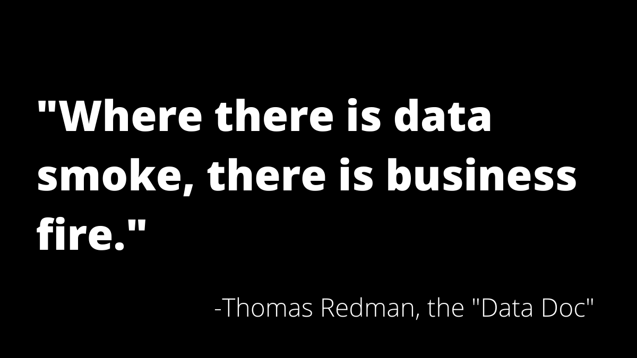

Alt-text: Web scrape eBay results using SerpApi where there is data smoke there is business fire quote

## Web scraping to the rescue

That is where web scraping comes to the rescue. [Web scraping](https://en.wikipedia.org/wiki/Web_scraping) is a form of **data extraction from**[**websites**](https://en.wikipedia.org/wiki/Website). It is typically an **automated process**, as to do it manually would take forever. Web scraping programs copy specific data from a web source and can store it in a central local [database](https://en.wikipedia.org/wiki/Database) or spreadsheet, for later [**retrieval**](https://en.wikipedia.org/wiki/Data_retrieval)**or**[**analysis**](https://en.wikipedia.org/wiki/Data_analysis). You can go and create your own web scraping bot with the use of:

* [BeautifulSoup](https://www.crummy.com/software/BeautifulSoup/bs4/doc/)
* [Scrapy](https://scrapy.org/)

but if you are not familiar with their interface and have not used them before, then it will be better, and more time efficient, if you use a service that can scrape the data for you.

[SerpApi](https://serpapi.com) is such a service. It is a **real time API service** that you can use to access [eBay](https://www.ebay.co.uk/) search results. It solves the issues of having to rent proxies, solving captchas, and does all the data parsing for you. You can play around in their [sandbox playground](https://serpapi.com/playground?engine=ebay) to see what it is that their API can provide. Let’s look at an example.

## An example using SerpApi

As a **coffee bean supplier**, you want to expand your service by adding some additional items to your supply list. You can conduct market research by looking at what coffee beans are popular with buyers on [eBay](https://www.ebay.co.uk/). The search criteria should include the following:

* 1kg in weight
* Arabica coffee beans
* Shipping needs to be free

You can also add **minimum and maximum prices** if you want to further decrease the search result amount. In the [sandbox playground](https://serpapi.com/playground?engine=ebay) the results of your search are given in [JSON](https://en.wikipedia.org/wiki/JSON#:~:text=JavaScript%20Object%20Notation%20(JSON%2C%20pronounced,or%20any%20other%20serializable%20value).) format. Below is an extract of one [eBay](https://www.ebay.co.uk/) search result:

8":

{

"title":"Brazilian Santos Arabica Green Coffee Beans Screen 17/18 size -1kg Free Delivery",

"link":"https://www.ebay.co.uk/itm/Brazilian-Santos-Arabica-Green-Coffee-Beans-Screen-17- 18-size-1kg-Free-Delivery/253245865298?hash=item3af6a13d52:g:4OwAAOSwMQBZ6wHI",

"condition":"Brand new",

"price":

{

"raw":"£8.99",

"extracted":8.99

}

,

"shipping":"Free postage",

"extensions":

[

"0":"",

"1":"144 sold"

]

For the purpose of this search, the `title` parameter needs to include the word `1kg` in the string, the `shipping` parameter needs to include the word `free` in the string and in the `extensions` parameter there needs to be an indication that it has sold a lot of items already on [eBay](https://www.ebay.co.uk/). In the SerpApi sandbox, the first 62 results of over 2000 results are shown in [JSON](https://en.wikipedia.org/wiki/JSON#:~:text=JavaScript%20Object%20Notation%20(JSON%2C%20pronounced,or%20any%20other%20serializable%20value).) format.

## Signing up with SerpApi

With a [SerpApi account](https://serpapi.com/#pricing) you can get access to all the search results that was generated with your search query, either in [JSON](https://en.wikipedia.org/wiki/JSON#:~:text=JavaScript%20Object%20Notation%20(JSON%2C%20pronounced,or%20any%20other%20serializable%20value).) format or HTML format. [JSON](https://en.wikipedia.org/wiki/JSON#:~:text=JavaScript%20Object%20Notation%20(JSON%2C%20pronounced,or%20any%20other%20serializable%20value).) files are easily [imported to an excel spreadsheet](https://support.office.com/en-us/article/import-data-from-external-data-sources-power-query-be4330b3-5356-486c-a168-b68e9e616f5a) for further analysis, or you can use it with your preferred data analysis tool.

The [SerpApi sandbox](https://serpapi.com/playground?engine=ebay) also has the helpful option of generating the search query code in your preferred programming language that you can just copy and paste in your script. An example of the python code is shown below:

from lib.google_search_results import GoogleSearchResults

params = {

"api_key": "your-api-key-here",

"engine": "ebay",

"ebay_domain": "ebay.co.uk",

"q": "1kg arabica coffee beans",

"_nkw": "1kg arabica coffee beans",

}

client = GoogleSearchResults(params)

results = client.get_dict()

## Conclusion

Now you can use this data files to **do data analysis** to see which coffee beans are the **most popular**, on [eBay](https://www.ebay.co.uk/), and add them to your supply list and start advertising the addition to your clients and **increase your revenue** and **competitive edge** in the coffee bean supply market!